**-ML System Design - Ad Click Predictions on Social Platforms**

Video: https://www.youtube.com/watch?v=wxUx3gIUEsk

Business Objective:

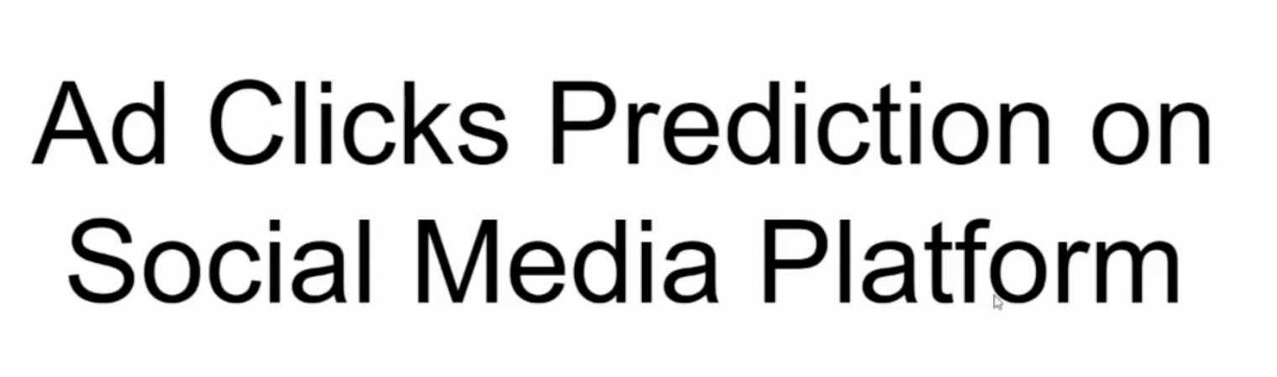

Ads on Different Platforms



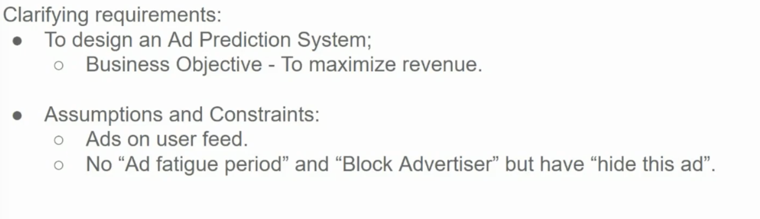

* Is there an existing system already in place?
* What is the main objective: accuracy, latency?
* Is there labeled data? If so, how much
* Can we trust the quality of data coming in?
* Where the model will be deployed? [cloud, edge, etc]
* Are there any constraints or limitations on model complexity or size?
* What are the key success metrics for this ML system in the long term?

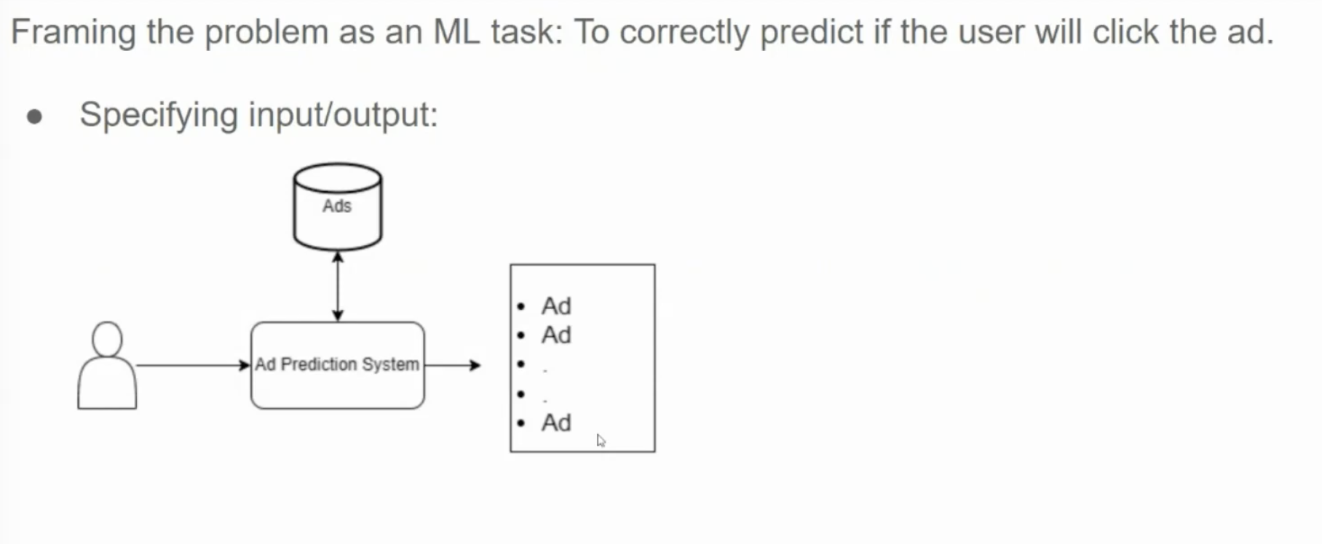

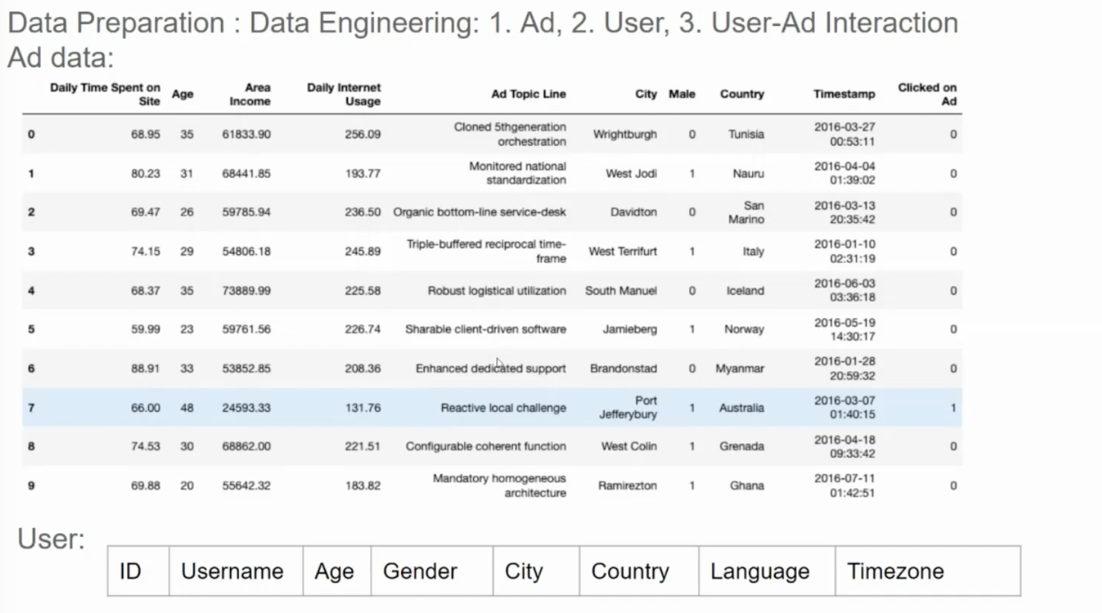

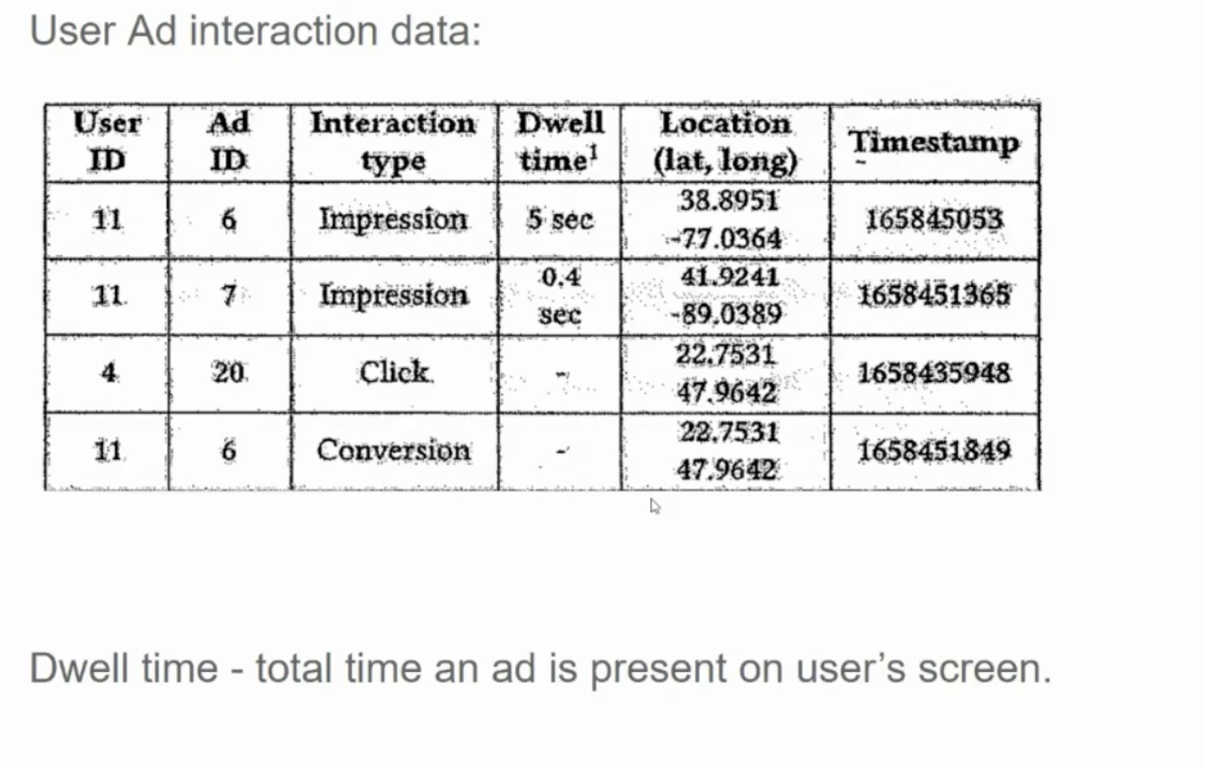

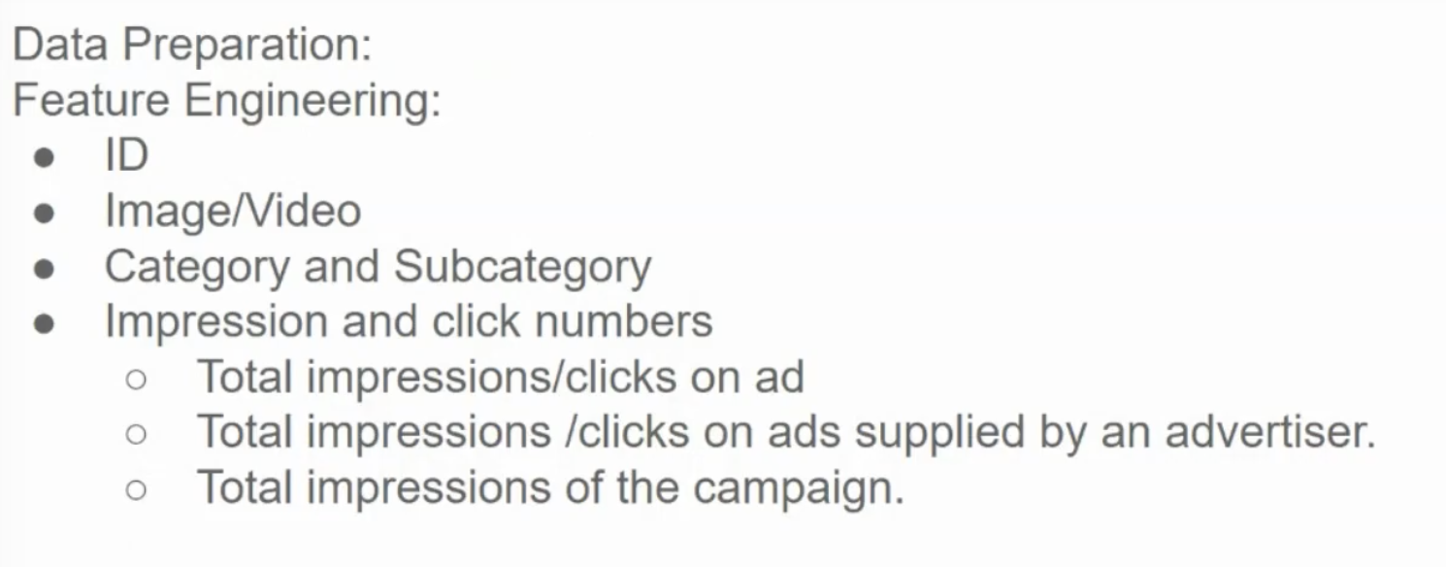

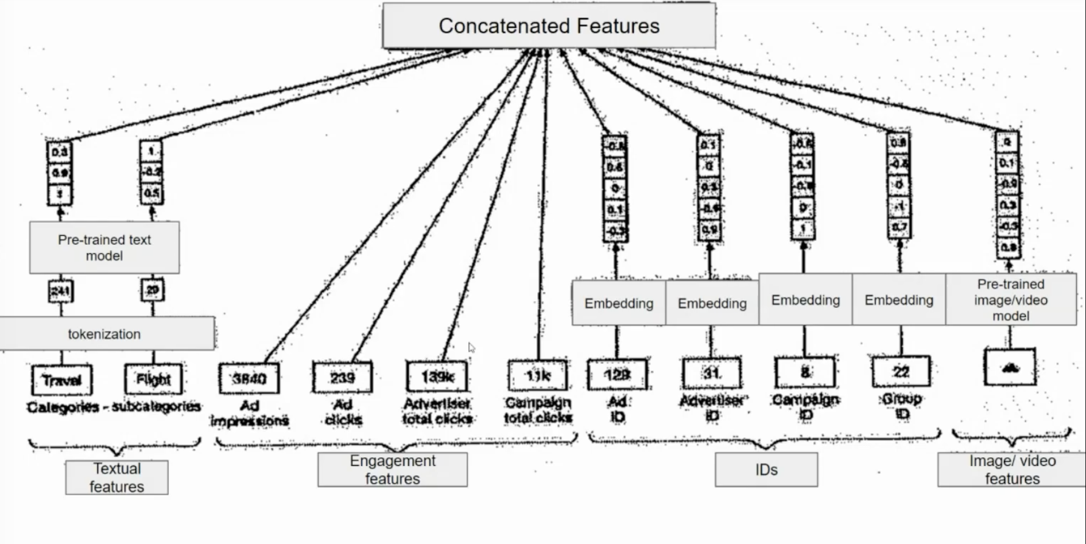

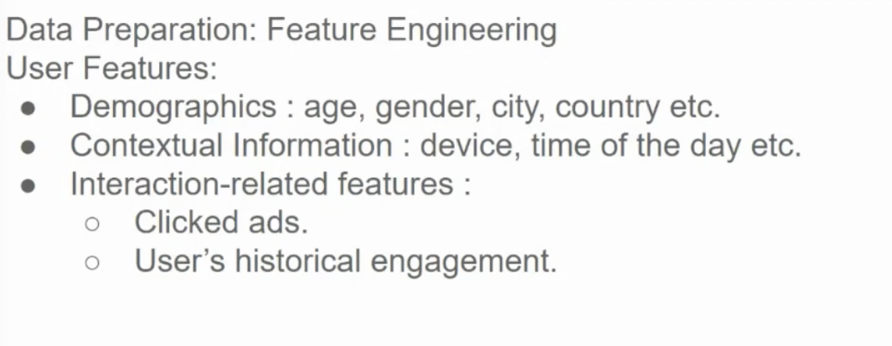

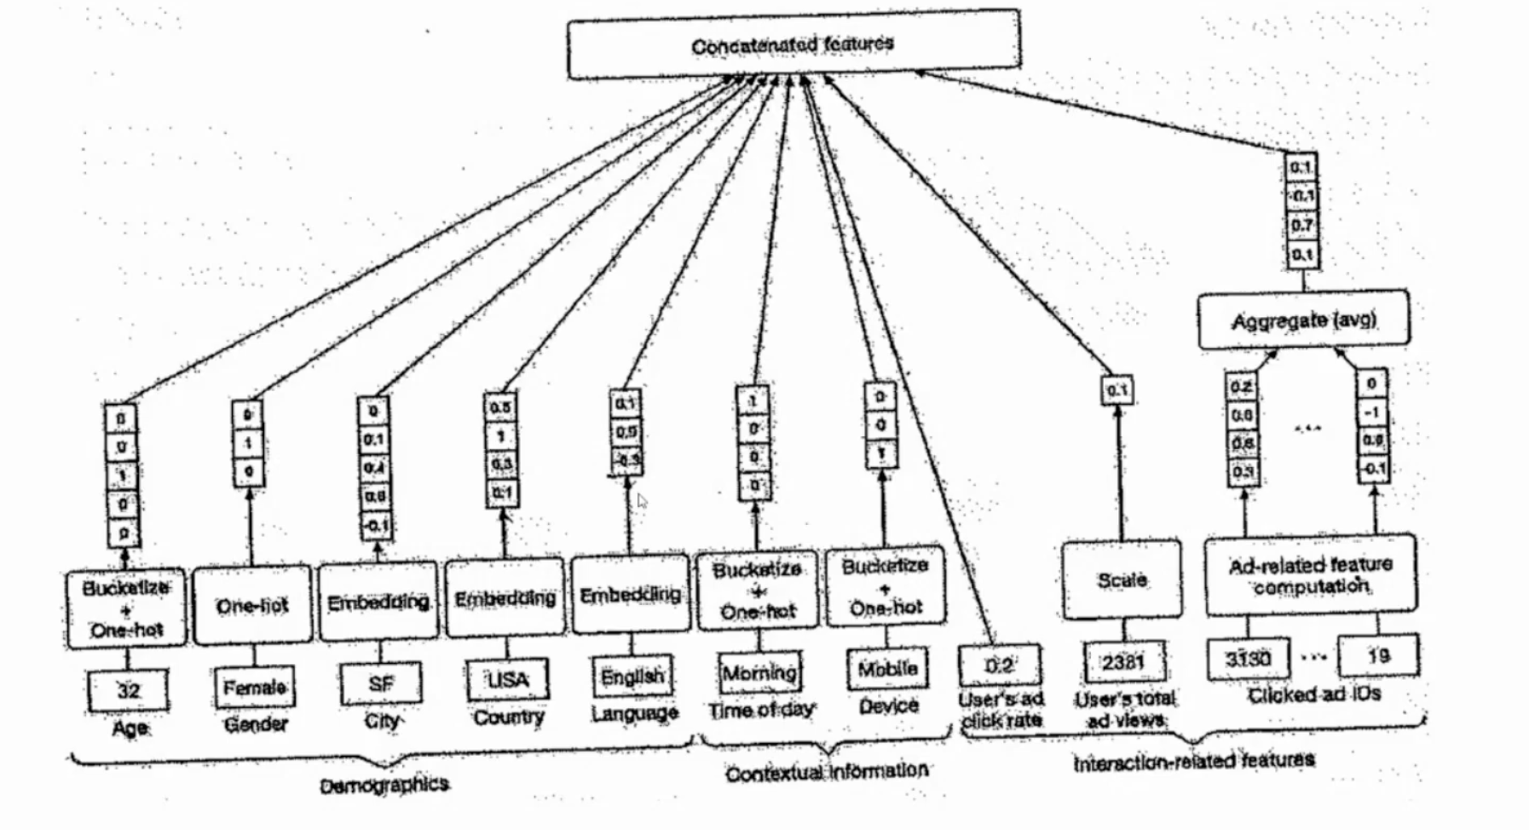

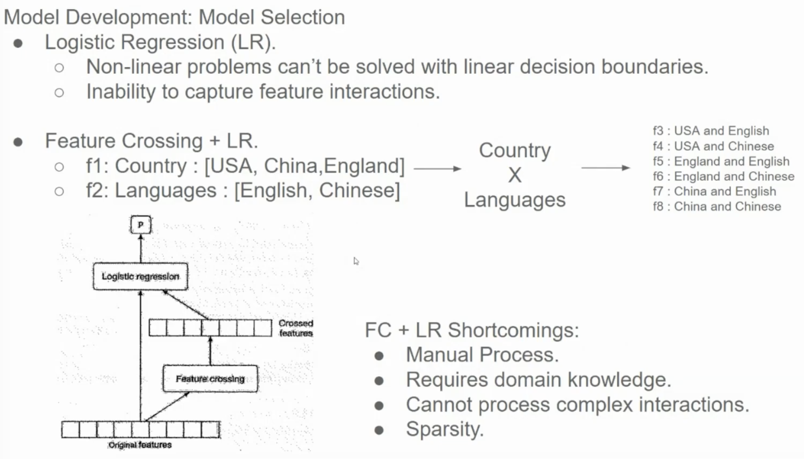

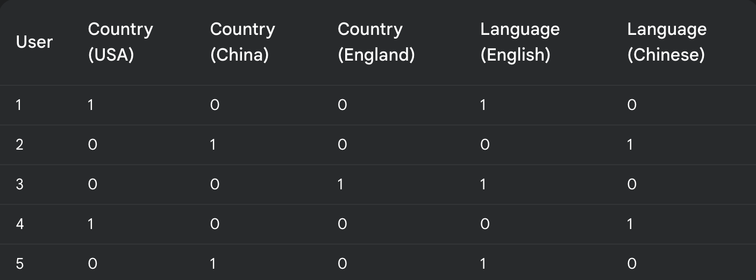

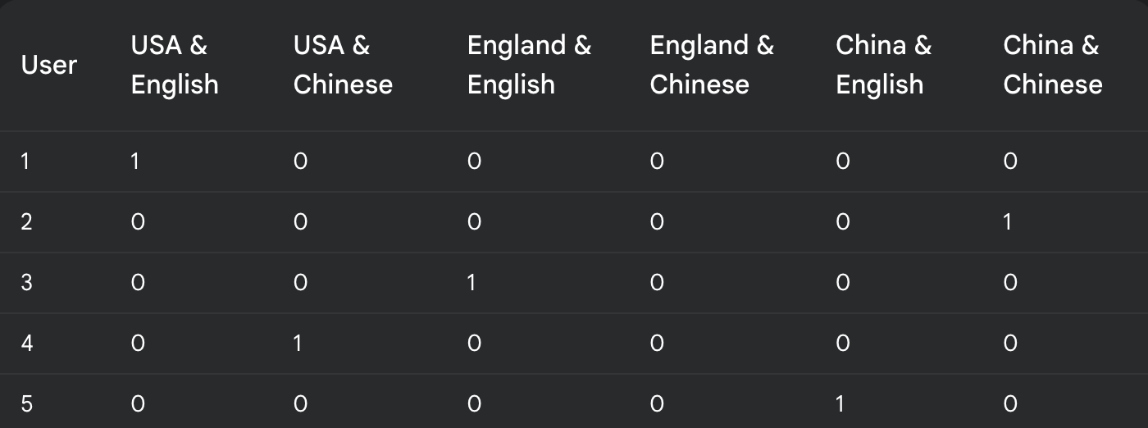

While automatically crossing *all* features removes the manual effort and domain knowledge requirement, it introduces these drawbacks:

* Combinatorial Explosion (Sparsity): The number of crossed features grows exponentially with the number of original features. This leads to extremely high-dimensional data, where most features are rarely seen (sparse data), making learning difficult and computationally expensive.
* Overfitting: With so many features, the model can easily overfit the training data, performing poorly on unseen data.
* Irrelevant Interactions: Not all feature combinations are meaningful. Crossing irrelevant features adds noise and can hinder performance.

Model: Step 1 – Candidate Generation

Here are some possible strategies for candidate generation in this context:

* **Rule-based filtering:** Use simple rules based on user demographics, interests, or context to filter the ad pool. For example:
  + Show ads for "running shoes" to users who have previously searched for "running gear."
  + Show ads for "local restaurants" to users based on their current location.
* **Keyword matching:** Match keywords in the user's query or profile with keywords associated with the ads. This is a common technique used in search advertising.
* **Content-based filtering:** If the ads have associated content (e.g., descriptions, images), use techniques like text similarity or image similarity to find ads that are relevant to the user's interests or the content they are viewing.

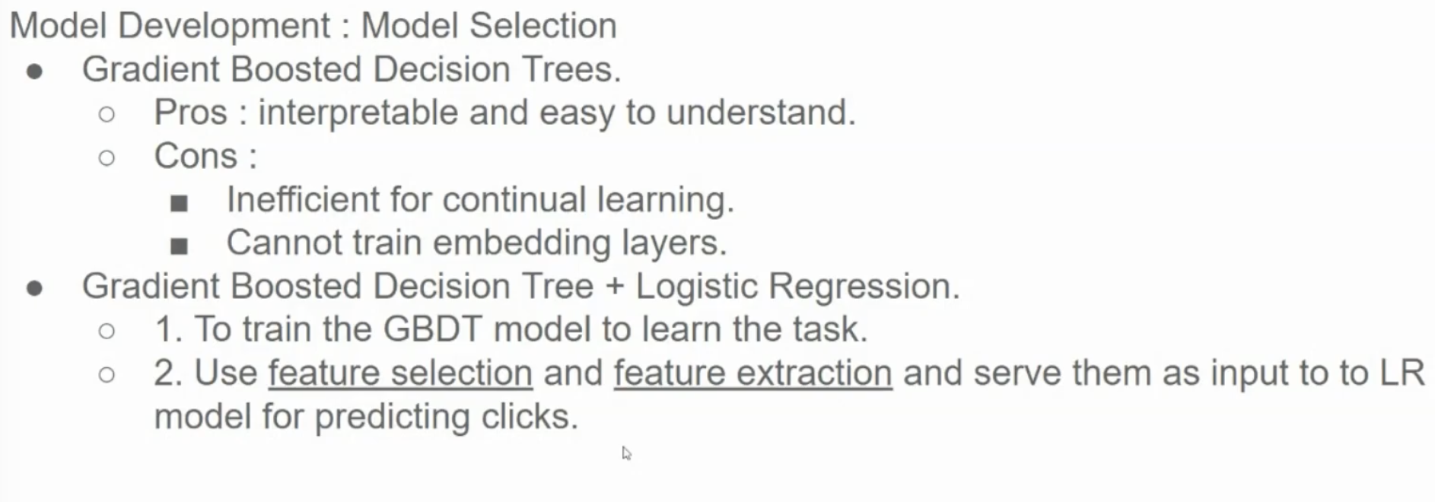

GBDTs train on the entire dataset at once, sequentially adding trees. Continual learning introduces new data incrementally. Retraining GBDTs on combined old and new data causes "catastrophic forgetting" (loss of prior knowledge). Retraining is computationally expensive. Methods like incremental tree updates exist but are complex and not a complete solution. Other models (e.g., neural networks with continual learning strategies) are generally better for continual learning.

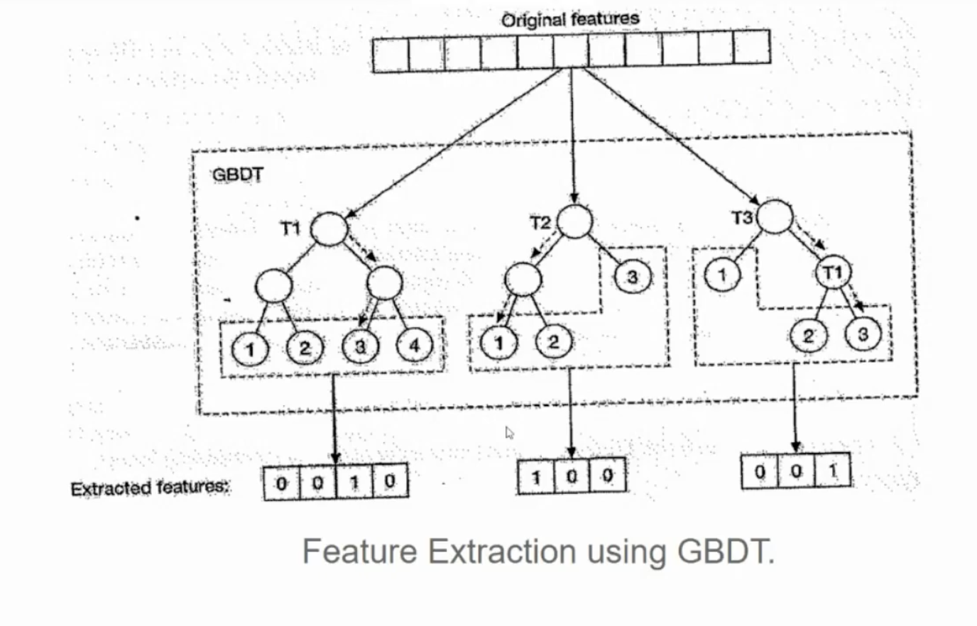

This diagram illustrates how Gradient Boosted Decision Trees (GBDTs) can be used for *feature extraction* or *feature transformation*. It's not showing a typical GBDT used for prediction but rather using the structure of the trees to create new features.

Here's a breakdown:

1. **Original Features:** The top row represents the original input features. These are the raw data that you would normally feed into a machine learning model.
2. **GBDT Ensemble:** The large box labeled "GBDT" represents an ensemble of decision trees (T1, T2, T3 in this case).
3. **Path Traversal:** For each data point (represented by the original features), you traverse each tree in the ensemble. The data point starts at the root node of each tree and follows the branches based on the feature values until it reaches a leaf node.
4. **One-Hot Encoding of Leaf Nodes:** The key idea is that each leaf node in each tree is treated as a new feature. If a data point ends up in a particular leaf node, that corresponding feature is set to 1; otherwise, it's 0. This is effectively a one-hot encoding of the leaf nodes.
5. **Extracted Features:** The bottom rows show the extracted features. Each row represents the output for a single tree. The "0010," "100," and "001" are examples of the one-hot encoded leaf node outputs.

**Example:**

Let's say a data point has feature values that cause it to:

* End up in leaf node 3 of tree T1.
* End up in leaf node 1 of tree T2.
* End up in leaf node 2 of tree T3.

Then, the extracted features would be:

* T1: 0010 (1 at the 3rd position)
* T2: 100 (1 at the 1st position)
* T3: 001 (1 at the 2nd position)

These extracted features can then be concatenated to form a new feature vector that represents the original data point.

**Why is this useful?**

* **Non-linear feature transformations:** Decision trees can capture non-linear relationships between features. By using the leaf nodes as features, you are effectively transforming the original features into a new feature space that captures these non-linearities.
* **Improved performance with linear models:** These extracted features can then be used as input to linear models like logistic regression or linear SVMs, which might perform better on these transformed features than on the original features.
* **Dimensionality reduction (sometimes):** If the number of leaf nodes is smaller than the original feature space, this can also act as a form of dimensionality reduction.

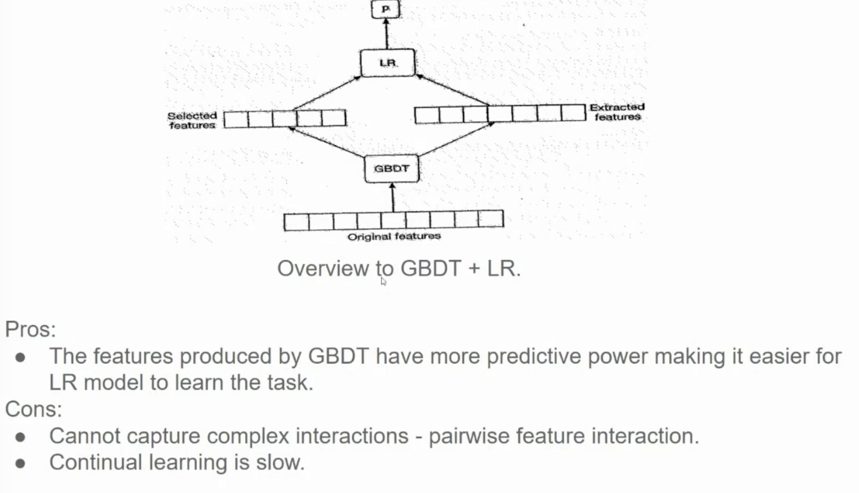

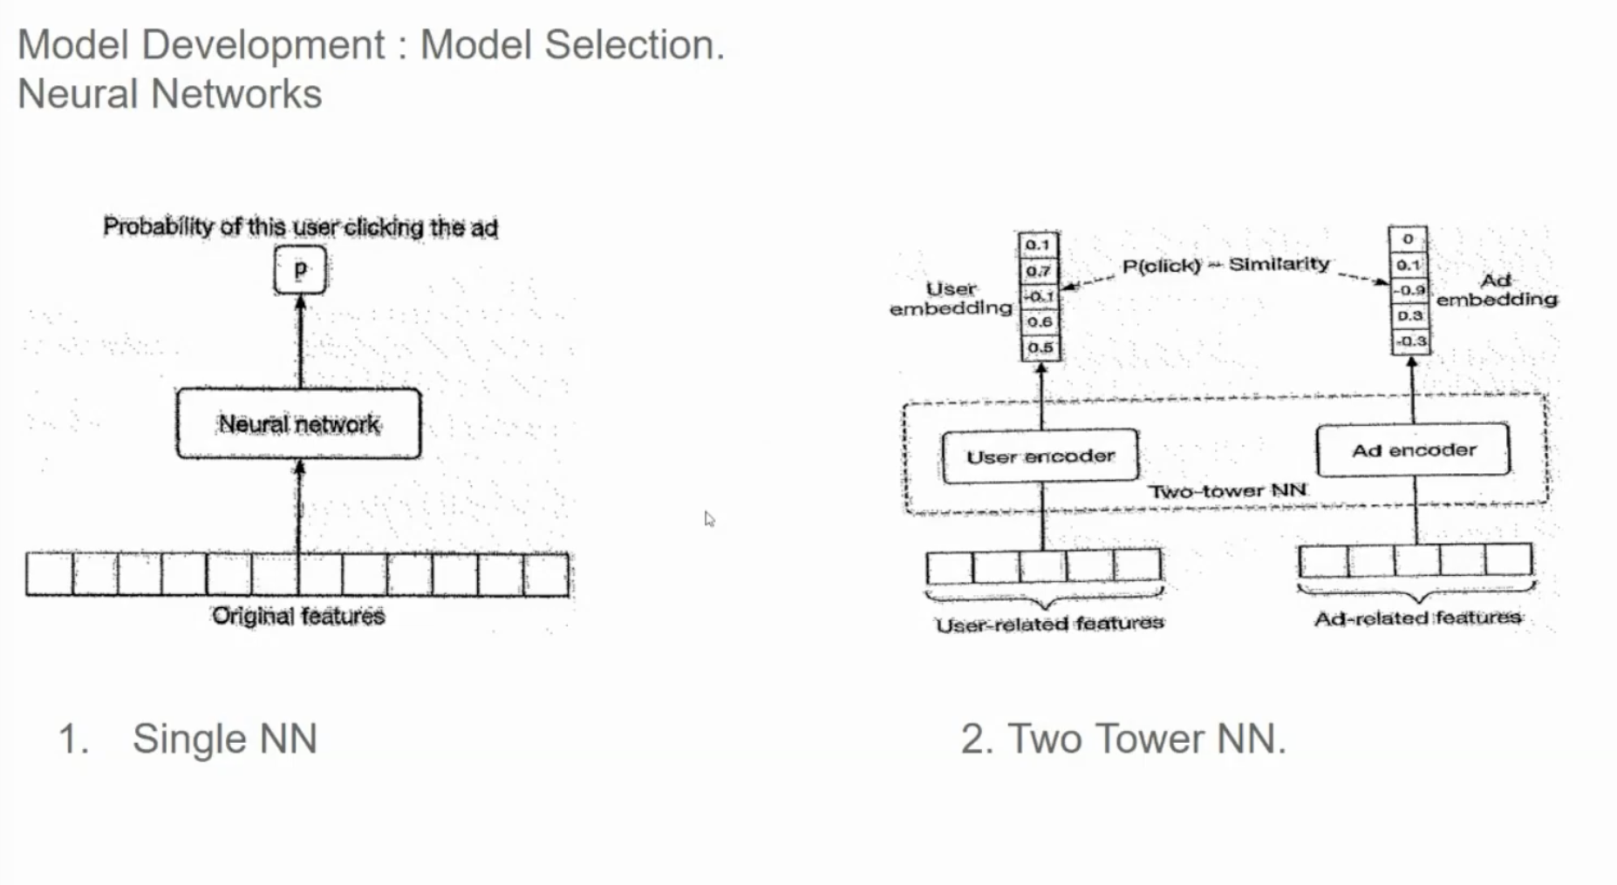

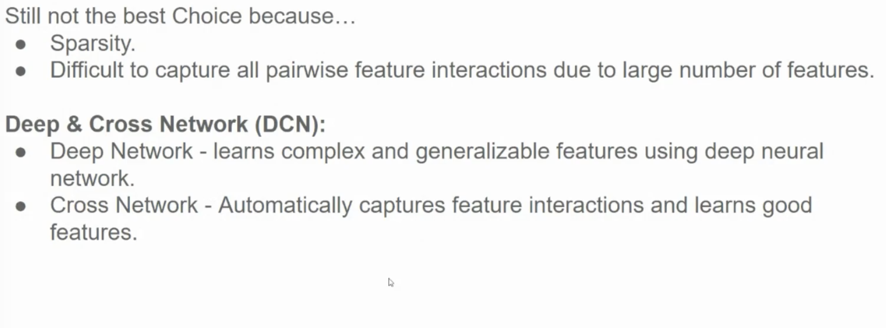

The Cross Network in DCN explicitly models feature interactions to capture complex relationships in data, complementing the Deep Network's hierarchical feature learning.

**Example Scenario:**

In an e-commerce recommendation system, features like **User Age**, **Item Price**, and **Item Category** interact. For instance:

* **Younger users may prefer lower-priced items.**
* **Specific genders might favor certain categories.**

**Cross Network Process:**

Let x be the original feature vector. At each layer, the Cross Network computes:

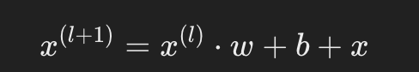

Where w (weights) captures interactions, and x (original input) ensures relationships are computed iteratively.

**Benefits:**

The network layers automatically learn interactions like:

* Younger females browsing low-priced fashion during sales.
* Middle-aged males browsing high-priced electronics.

By explicitly modeling interactions, the Cross Network avoids manual feature engineering, making it efficient for tasks like recommendations, especially when paired with the Deep Network for generalization.

**Cross Network in DCN:**

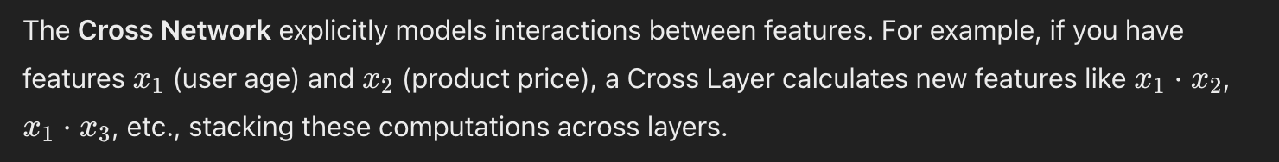Each layer refines the feature interactions by adding context or depth:

1. **First Layer**: Learns basic pairwise interactions (e.g., age * price).
2. **Second Layer**: Builds on the first, learning interactions like "age * price * category."
3. **Further Layers**: Add higher-order interactions iteratively.

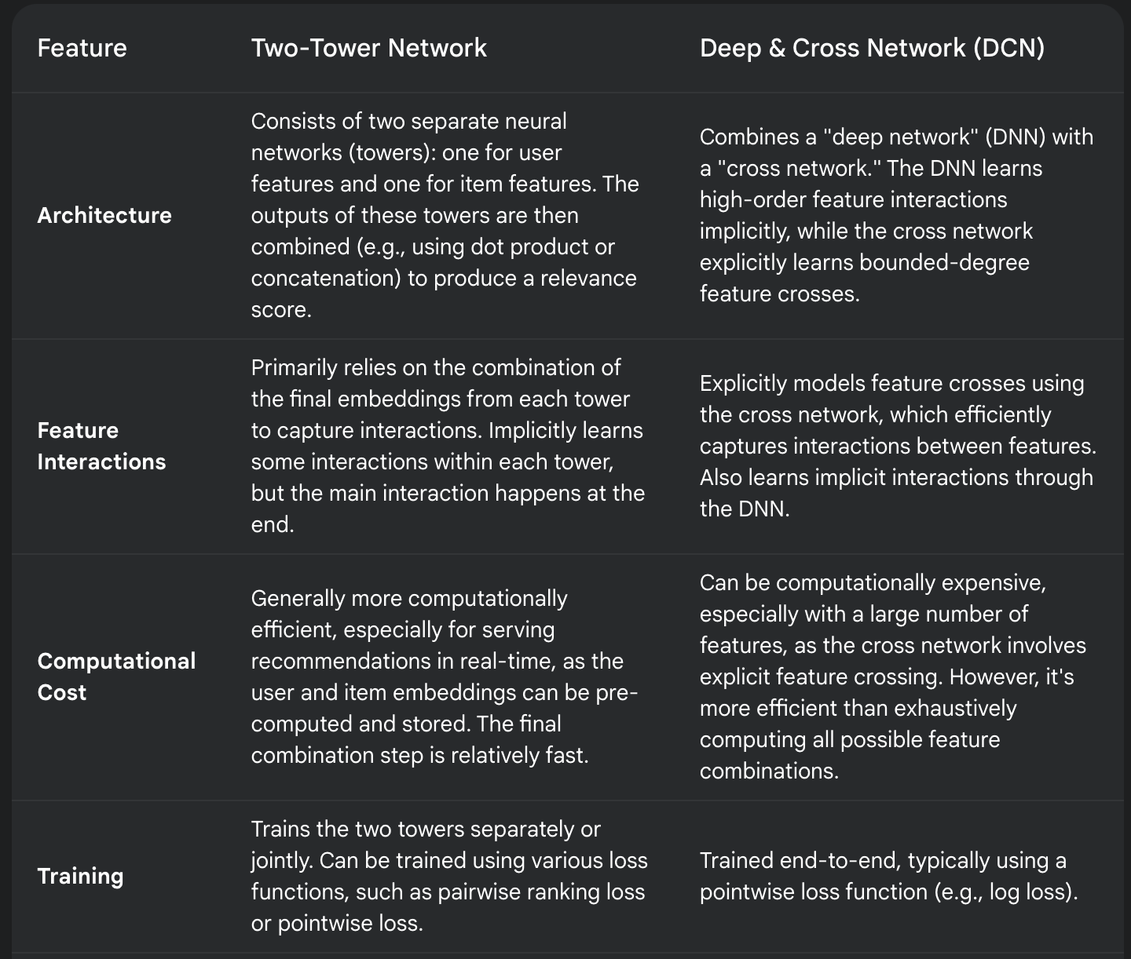

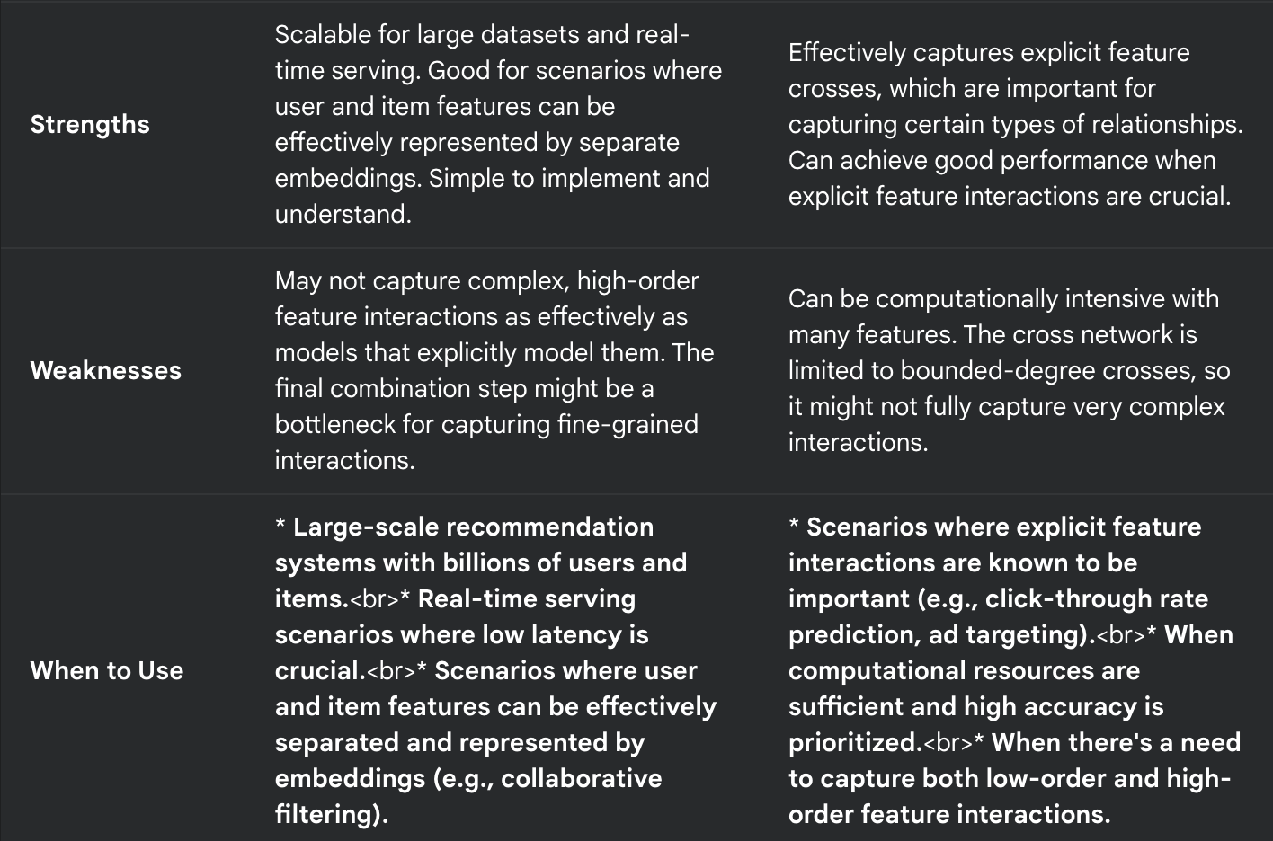

• **Two-Tower:** Imagine having separate profiles for users and items. The Two-Tower model learns "summaries" (embeddings) of these profiles and then compares them to see how well they match. This is fast and scalable.

• **DCN:** Imagine having a detailed spreadsheet where you list all possible combinations of user and item features. DCN tries to learn which combinations are most important for making predictions. This is good for capturing specific relationships but can be more computationally intensive.

More reading on DCN: https://mlfrontiers.substack.com/p/the-rise-of-deep-and-cross-networks

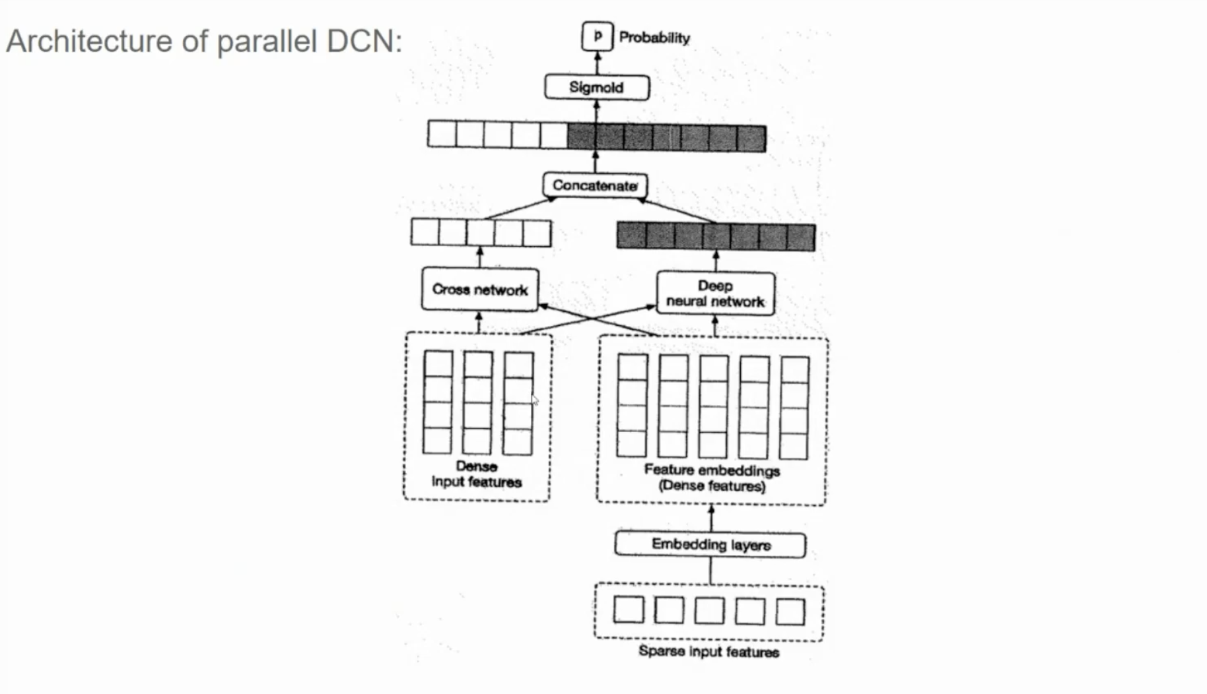

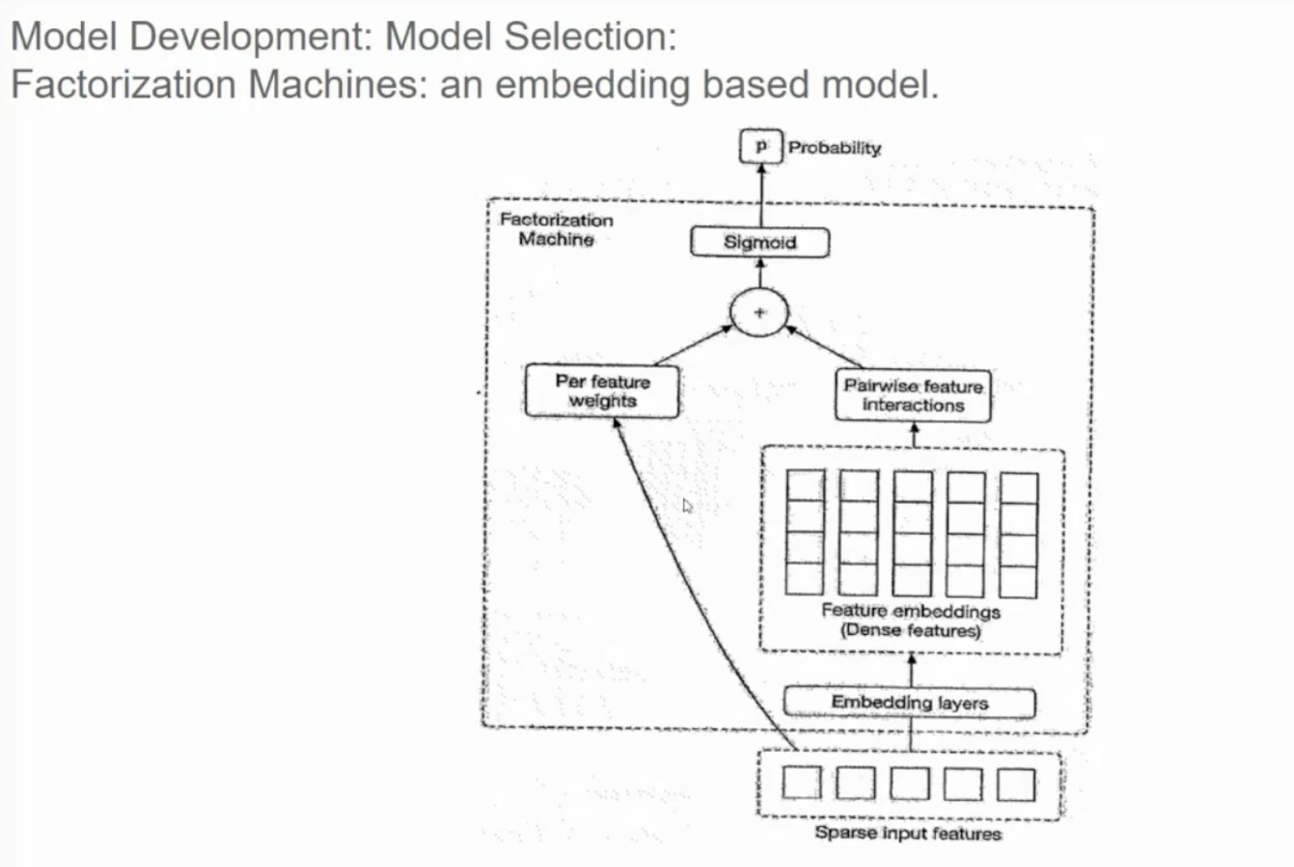

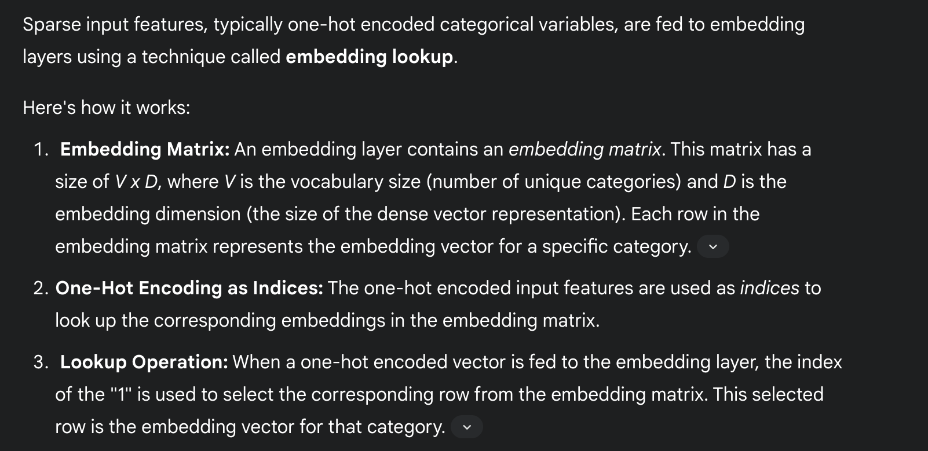

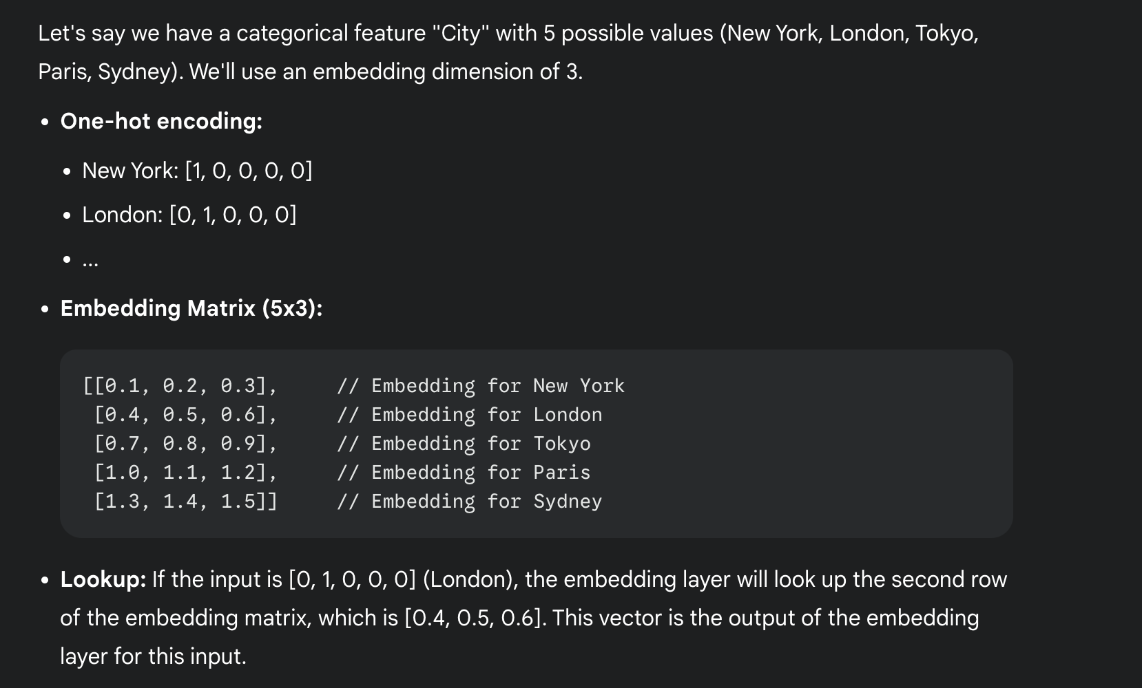

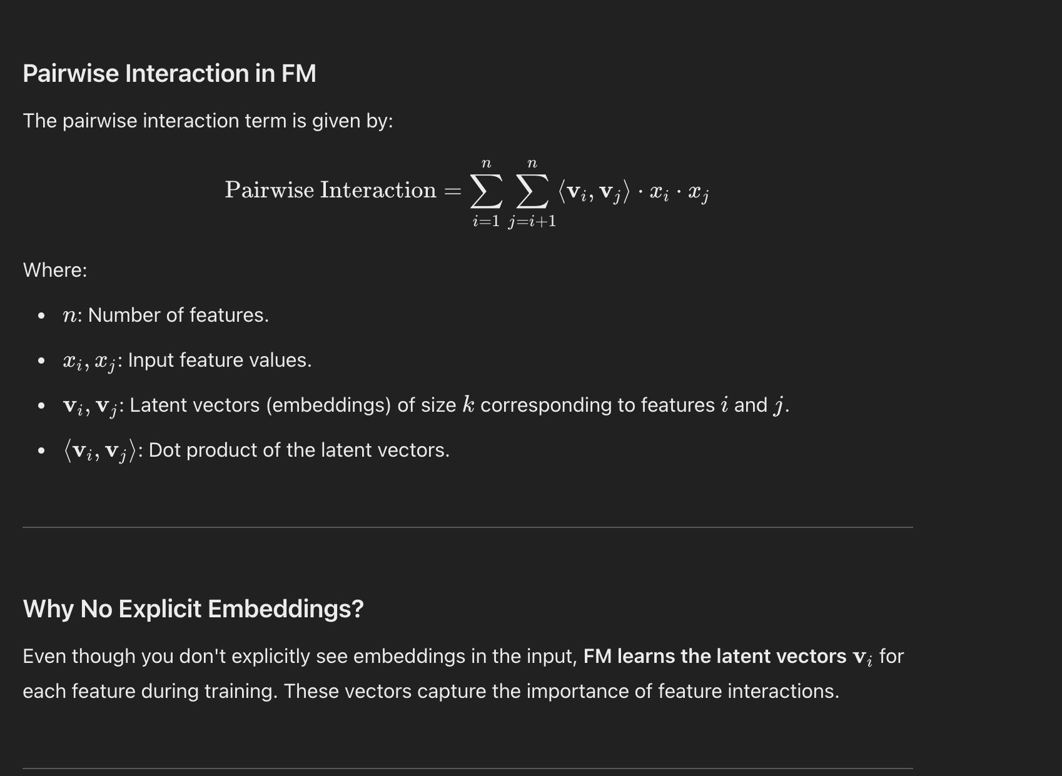

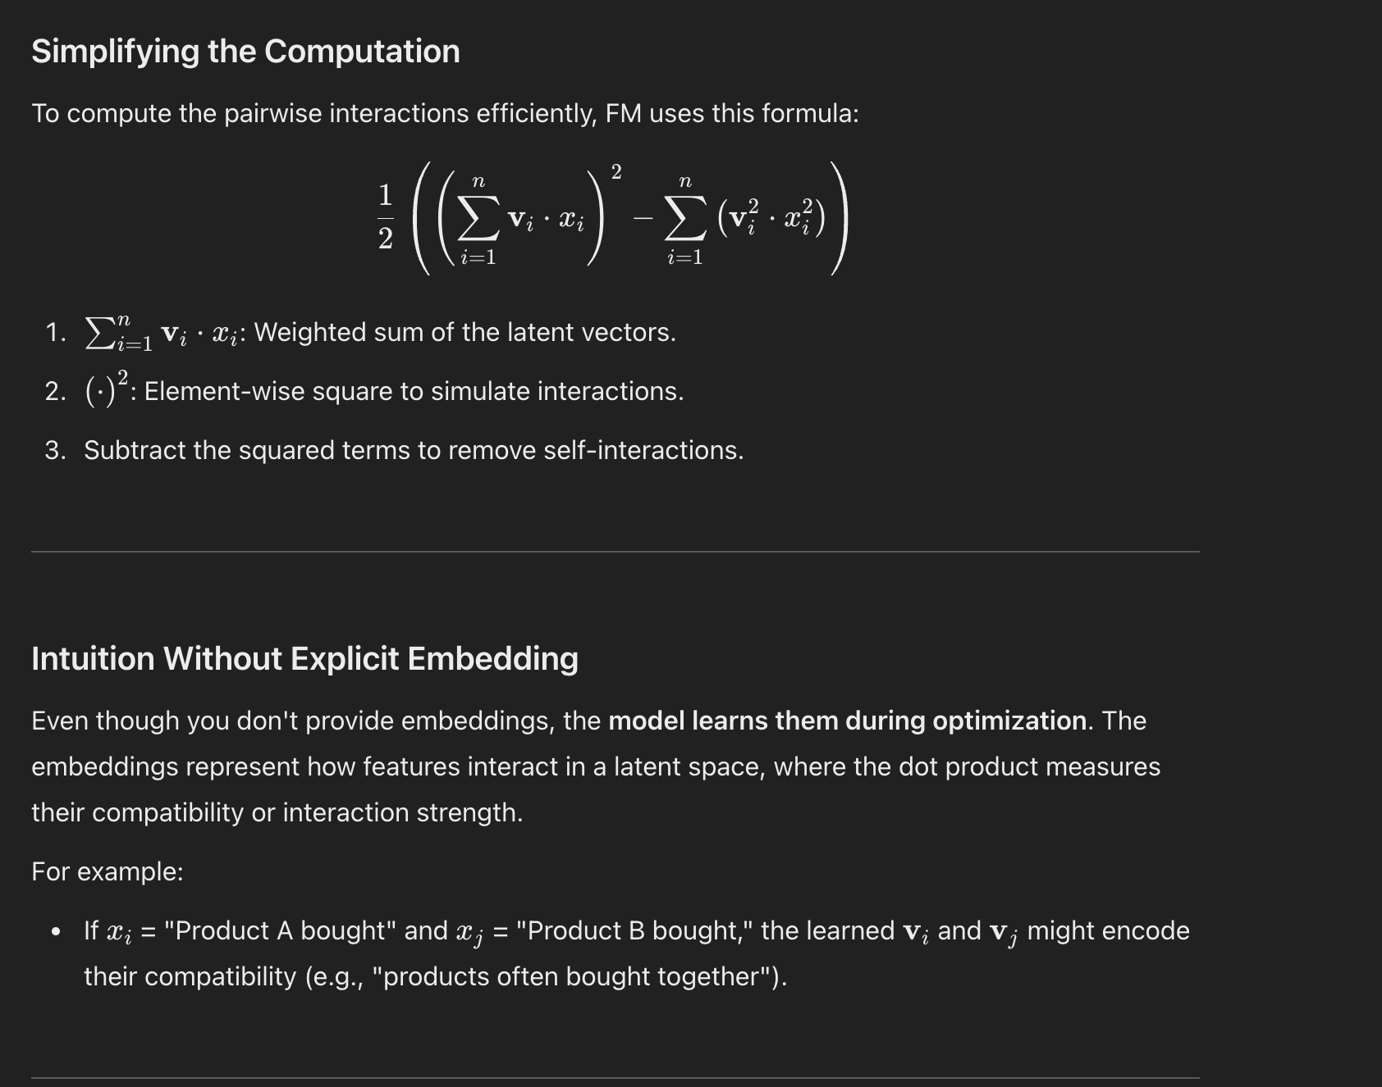

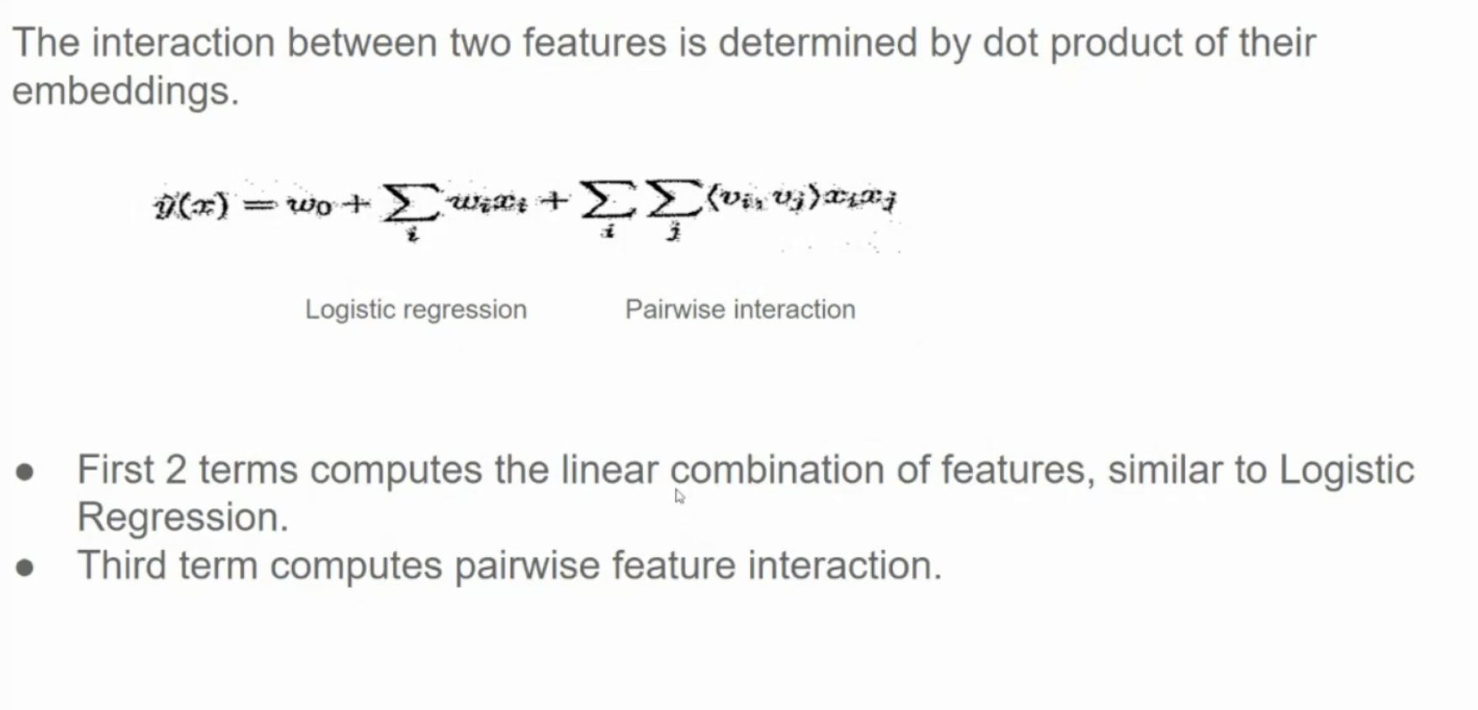

More on FM: https://www.youtube.com/watch?v=rtKtZpXQSZg

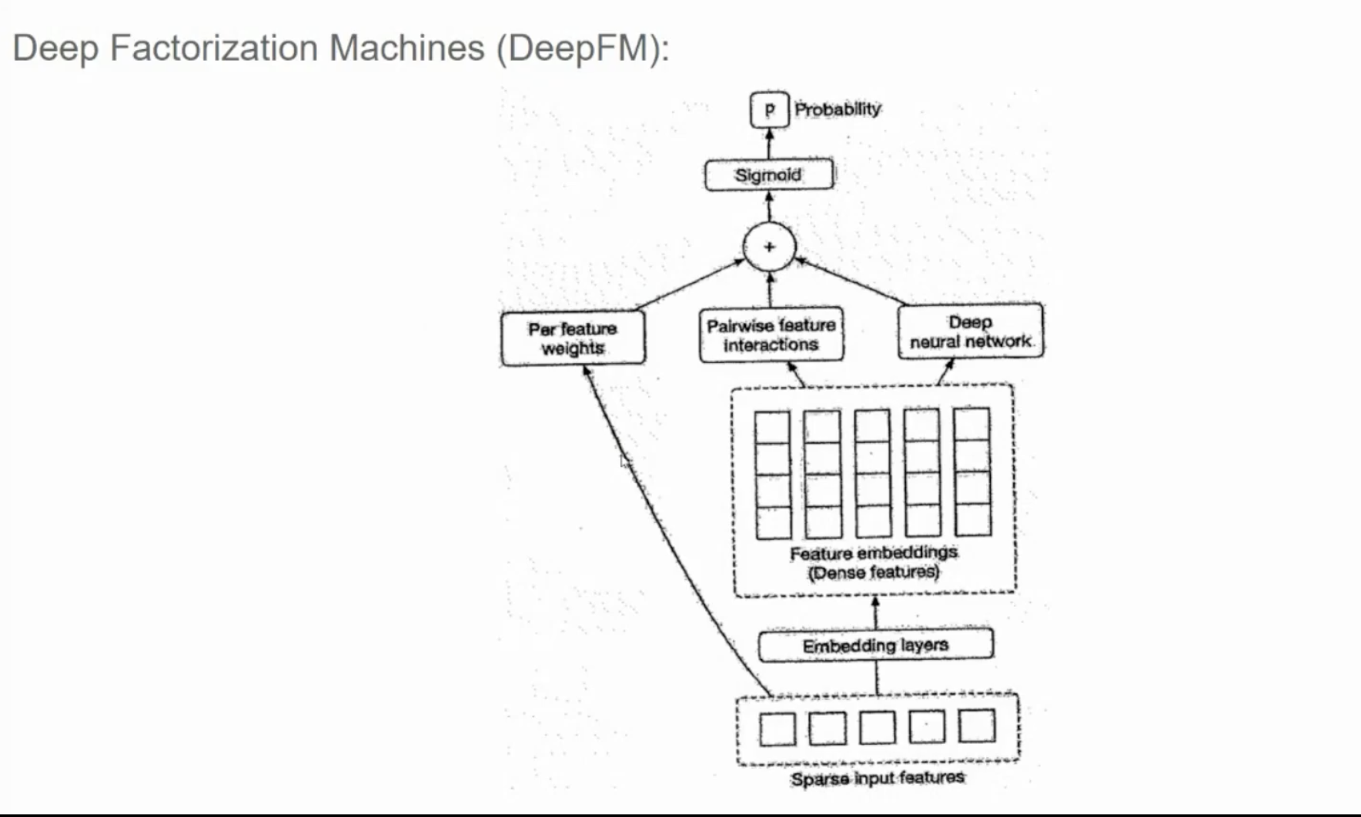

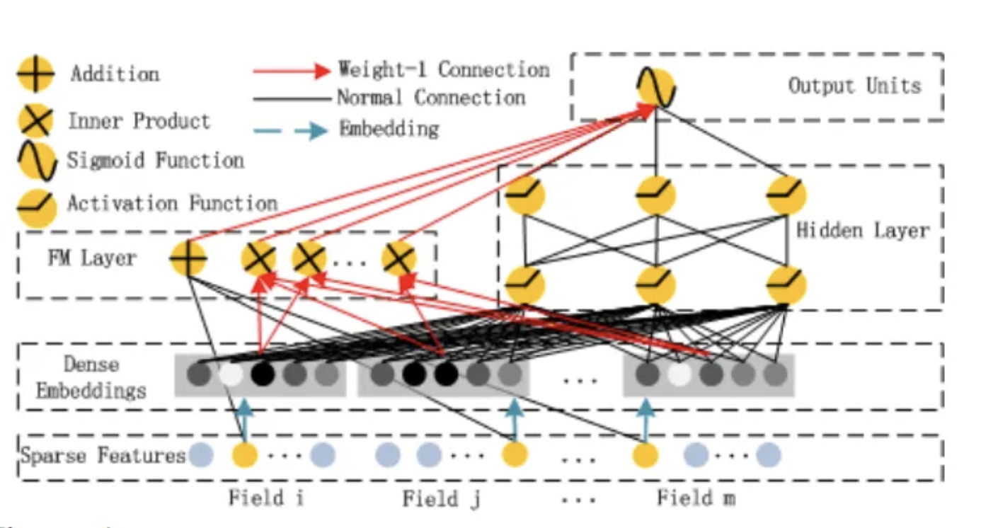

Watch video on DeepFM: <https://www.youtube.com/watch?v=w_YSl0Gd5CA>

Read this: https://medium.com/data-science-in-your-pocket/deepfm-for-recommendation-systems-explained-with-codes-c200063990f7

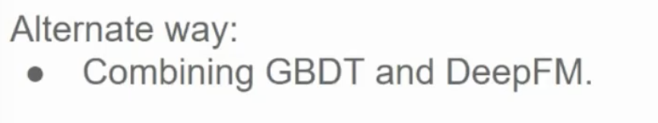

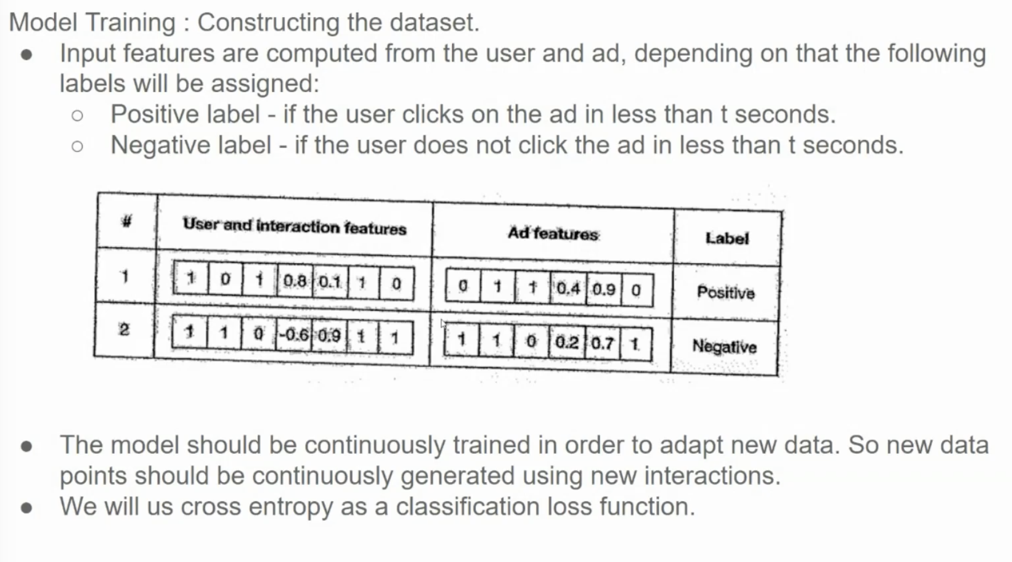

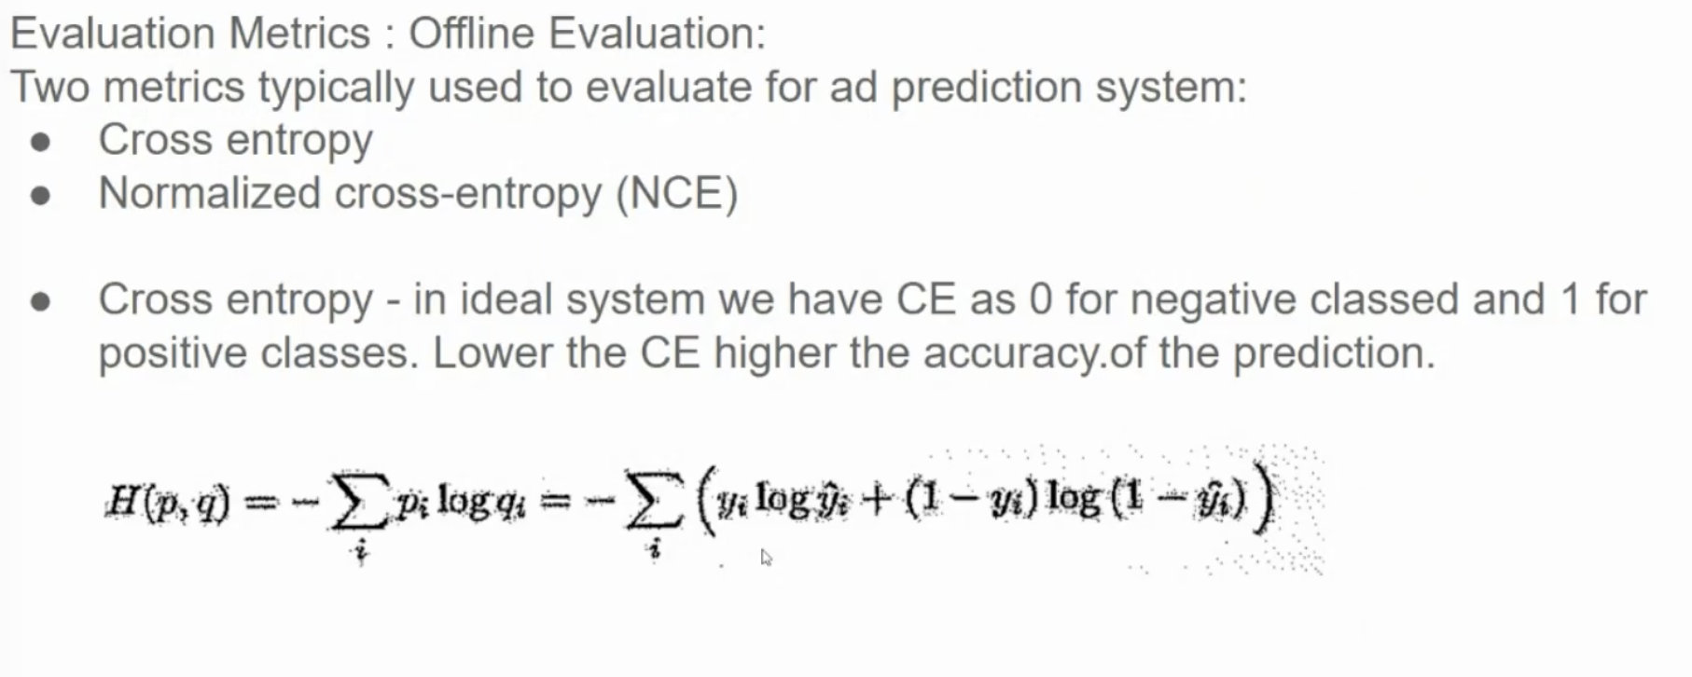

**Area Under the ROC Curve (AUC):** This is a very common metric for binary classification tasks like click prediction. It measures the ability of the model to distinguish between positive and negative examples. A higher AUC is better (closer to 1).

